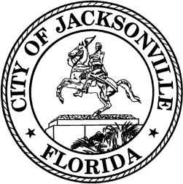

OFFICE OF THE CITY COUNCIL

COUNCIL MEMBER JIMMY PELUSO  DISTRICT 7  OFFICE (904) 255- 5207  FAX (904) 255-5230 | SUITE 425, CITY HALL  117 WEST DUVAL STREET JACKSONVILLE, FL 32202  E-MAIL: JPELUSO@COJ.NET

Amended
MEETING NOTICE

Notice is hereby given that Council Member Jimmy Peluso will host a noticed meeting on January 29, 2026, at 4:00 p.m., in the Lynwood Roberts Room on the first floor of City Hall at 117 West Duval Street, Jacksonville, FL 32202 to discuss the Duval County List of Priority Projects (LOPP) related to transportation improvements and other matters. This meeting is open to the public and all interested parties are welcome.

For additional information, please contact Brooks Dame at bdame@coj.net or (904) 255-5135.

Accommodation Requests:
Pursuant to the American with Disabilities Act, accommodations for persons with disabilities are available upon request. Please allow 1-2 business days for a notification to process; last- minute requests will be accepted but may not be possible to fulfill. Please contact Disabled Services Division at: VM (904) 255-5466, TTY (904) 255-5475, or email your request to KaraT@coj.net.

JP/bd

NOTICED ON: January 23, 2026, at 1:30 p.m., pursuant to 15.103(c), Ordinance Code.

cc: Council Members and Staff
Jason Teal, Director/Council Secretary
Bernadette Smith, Chief, Legislative Services Division Teresa Eichner, Chief, Public Information Division Yvonne Mitchell, Chief, Administrative Services Division
Colleen Hampsey, Chief, Research Division CITYC@COJ.NET
Electronic Notice Kiosk – 1st Floor City Hall Public Notice System – City Council Web Page Media Box
File Copy

